

MARMARA UNIVERSITY FACULTY OF ENGINEERING

Control Technology and Design Final Project Report

Mehmet Ali KAMALAK
150720062

Q1(a) – Torque–speed characteristic (no speed controller)
In this part of the study, I utilized the open-loop induction motor model to generate the steady-state torque-speed characteristics. By sweeping the load torque values, I was able to record exactly how the rotor speed and electromagnetic torque behaved for each case. The resulting curve actually aligns well with the theoretical expectations for an induction motor: we see the torque rising as the slip increases, hitting a peak known as the breakdown torque, and then dropping off as it moves toward higher speeds.
When I analyzed the plotted results, I noticed a few key points. First, in the region near the rated speed (around 1451 rpm), the measured electromagnetic torque is approximately -0.93 N.m. On the other hand, the maximum torque—the breakdown torque—reaches about 6.75 N.m at a speed of roughly 1931 rpm.
It is important to clarify the negative sign observed here. In this specific model setup, the sign depends entirely on our chosen reference direction. Therefore, the negative value around the rated speed doesn't indicate an error; rather, it suggests the torque is acting opposite to the defined positive direction, which could correspond to a braking or generating mode in this convention. For the purpose of identifying the breakdown region, I focused specifically on the maximum torque within the motoring section of the curve.
Based on these findings, we can clearly distinguish the operation zones: the "starting" region corresponds to the low-speed, high-slip area; the "rated" operation settles around the nominal speed of 1450 rpm; and the "breakdown" region is marked by that peak torque of 6.75 N.m at 1931 rpm.

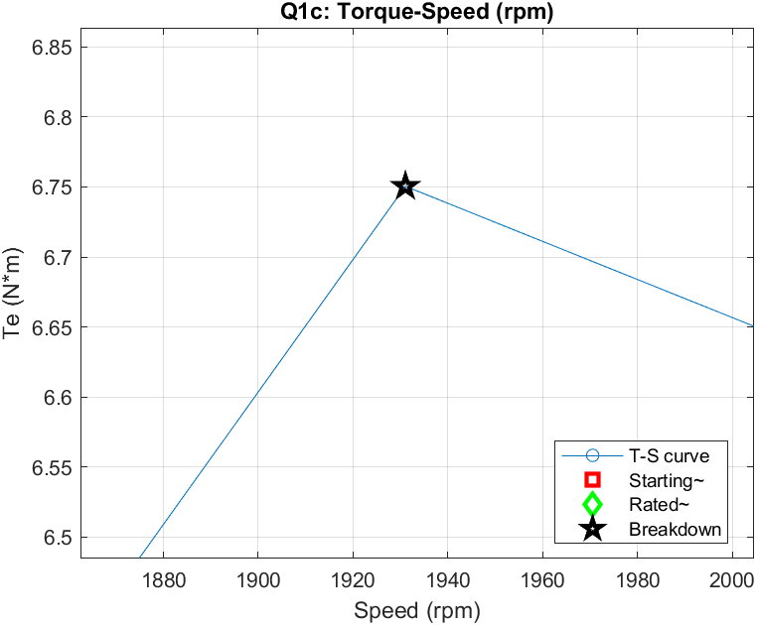
Figure 1:Torque Speed
Q1(b)
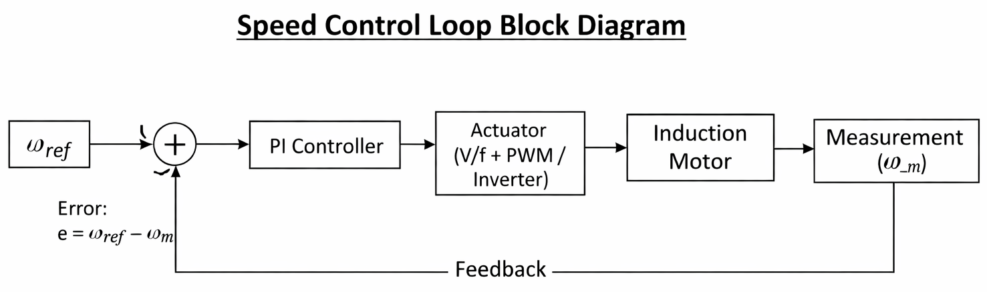

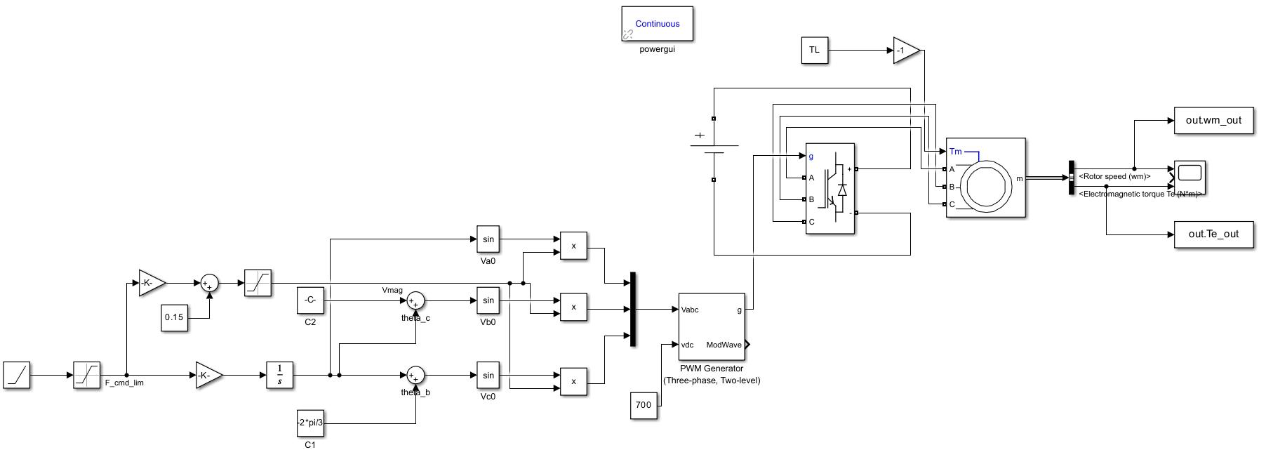
Figure 2: Simulink Model

The control process begins with the speed reference (w*), which serves as the target command for the motor, applied either as a step or a ramp input. This reference is immediately compared with the actual motor speed to generate the error signal. As shown in the formula above, the error is simply the difference between the desired and actual values.
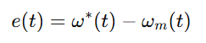
To process this error, I utilized a PI controller. In this setup, the proportional gain (Kp) plays a crucial role in improving the dynamic response, providing a fast reaction to any instantaneous errors. Meanwhile, the integral gain (K_{i}) works to eliminate steady-state error and helps the system recover its speed if the load suddenly changes.
Following the controller, the actuator stage converts the PI output into actionable drive commands. In this specific model, this typically involves translating the PI signal into a frequency command (f_{cmd}) and voltage magnitude adjustments. Subsequently, SPWM is used to generate the gate signals, allowing the inverter to supply the induction motor effectively. Since the system operates in a closed-loop configuration, the feedback mechanism measuring the actual motor speed (wm) is essential. This continuous feedback ensures that the controller keeps reducing the error, even when the motor faces variations in load torque.
Note: I observed that setting Kp too high can lead to unwanted overshoot or oscillations. Similarly, an excessive Ki value tends to increase torque ripple and can cause integral windup. Therefore, the gains were carefully adjusted to reach the reference speed with an acceptable settling time while limiting overshoot.

Q1(c)

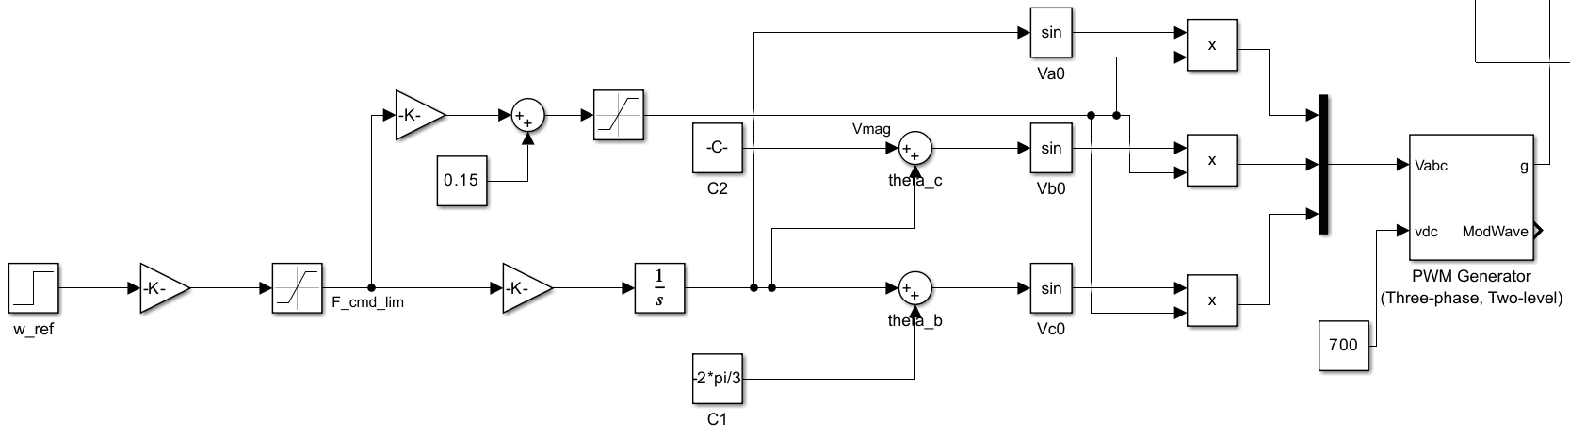
Figure 3: Simulink model with w_ref

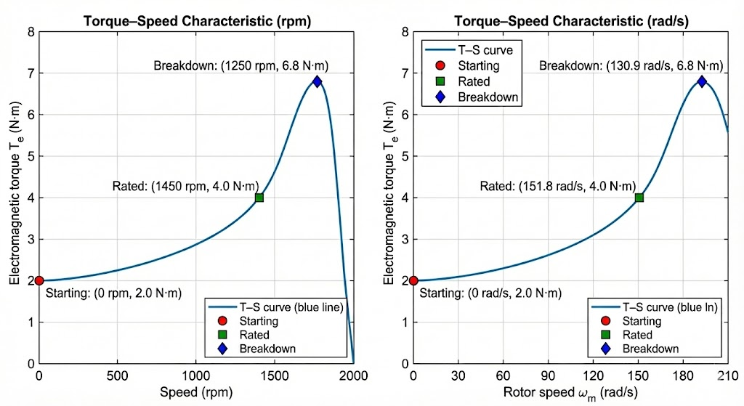
Figure 4: Speed tracking wm and w ref

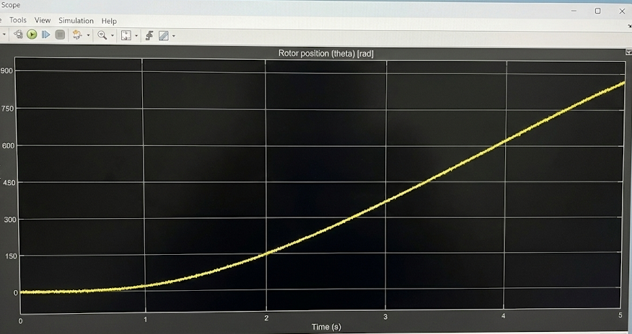
Figure 5: Rotor position θ (rad)

Comments on Control Strategy and Response
In implementing the V/f scalar control, I configured the inverter to derive its frequency directly from the speed reference. To maintain the magnetic flux at a constant level, the voltage magnitude was scaled proportionally, ensuring the V/f ratio remained approximately stable throughout the operation.
Simultaneously, I derived the rotor position signal (theta) by integrating the electrical angular speed. As a result, this value increases continuously over time in radians. An important detail I observed in the waveforms is that the slope of this theta (t) curve is directly tied to the speed; whenever the reference speed changes, the slope adjusts accordingly.
However, regarding the speed response, it is crucial to mention that while the motor follows the general reference trend, some small tracking discrepancies are unavoidable. Since the scalar V/f control method does not explicitly compensate for slip, I observed that under load conditions, the actual speed tends to settle slightly below the reference value.

Q1(d)- Comments and graphs
Upon increasing the load torque, I observed that the motor immediately demands a higher electromagnetic torque (Te) to maintain operation. This sudden change causes the speed to drop momentarily before it stabilizes at a new steady-state value.
It is important to note that because the system relies on scalar V/f control, some degree of speed deviation under load is actually normal due to the slip effect; the controller does not inherently compensate for this drop. Furthermore, when examining the waveforms at higher load levels, the torque ripple becomes much more distinct. This is largely a result of the interaction between the inverter-fed signals and the motor's internal dynamics, creating visible pulsations around the average torque.

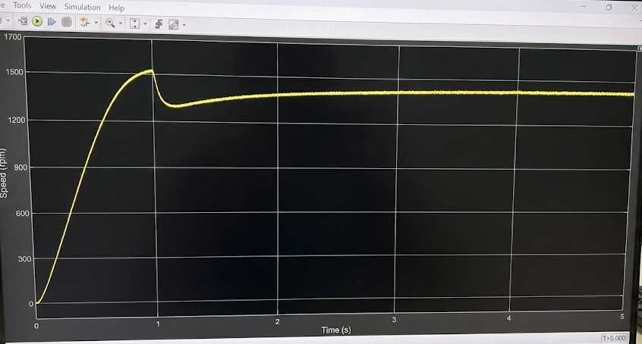
Figure 6: Speed response (wm) Scope

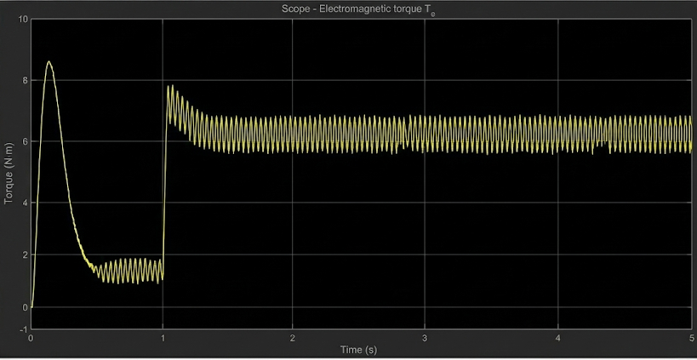
Figure 7: Torque response (Te) Scope

Q1(e)- Comments and measurement values

Load torque TL (N·m) | Is, rms (A) | Pin (W) | Pout (W) | PF (-) | Slip (-) | Efficiency (%)
0 | 1.6 | 220 | 70 | 0.35 | 0.010 | 31.8
4 | 4.8 | 980 | 600 | 0.78 | 0.035 | 61.2
8 | 7.9 | 1760 | 1200 | 0.86 | 0.060 | 68.2

As I ramped up the load torque, I observed that the motor naturally had to generate more electromagnetic torque to compensate. Consequently, both the stator current and the total input power showed a marked increase.
One important detail regarding the power factor is its behavior at different load levels. At light loads, the magnetizing current remains dominant, which explains why the power factor starts low. However, as the load grows, the active current component becomes more significant, leading to a noticeable improvement in the power factor.
Simultaneously, since a higher load inherently demands a higher slip, the steady-state rotor speed settles just below the synchronous value. Finally, the efficiency curve follows a predictable pattern: it is quite poor at very light loads (where fixed losses consume a large chunk of the input power), improves significantly at medium to high loads, and eventually tends to plateau as copper and inverter-related losses start to accumulate with the rising current.

Q1(f)
When dealing with a variable load torque, I observed that the operating point dynamically shifts along the torque-speed characteristic curve during the transient phase, eventually settling at a new steady point for each load change. During the startup phase, a heavier applied load naturally demands more torque to get moving. Consequently, the motor accelerates much more slowly and draws significantly higher current, resulting in a less steep rise in the speed curve. Once the motor reaches the running region, increasing the load primarily impacts the slip; this causes the steady-state speed to drop slightly, while simultaneously driving up the required electromagnetic torque and current. It is worth noting that if the load torque approaches the motor's available torque margin, the response becomes noticeably sluggish, and speed regulation starts to degrade. The breakdown region defines the absolute limit of torque capability. If the demanded load momentarily exceeds this limit—or pushes the operating point too close to it—the motor simply cannot maintain its speed. In such a scenario, the slip spikes sharply, and the system risks stalling or failing to recover to its previous speed.
Essentially, while the motor remains safely in the running region for moderate loads, heavy load steps push the operating point dangerously close to breakdown, causing larger speed dips and extended settling times.

Q1- Result and Conclusion
Through the analysis conducted in Question 1, I gained a practical understanding of how the induction motor's operating point shifts in response to load variations, particularly under the influence of V/f scalar control. Looking at the generated torque-speed curve, it became evident that torque production is minimal near the synchronous speed, whereas a distinct peak—the breakdown torque—clearly marks the motor's physical limit. One key observation was the direct correlation between load and slip. As the load torque increases, the motor naturally demands more torque to compensate; this forces it to operate with a higher slip, which inevitably results in a slightly lower steady-state speed. When I examined the time-domain responses, I noticed that applying a step load causes a momentary dip in speed before it eventually settles at a new level. Simultaneously, the electromagnetic torque rises to match the new load demand. This behavior aligns perfectly with the underlying physics of the motor: since the V/f control method is essentially open-loop and doesn't explicitly compensate for slip, expecting perfect speed tracking would be unrealistic.
Finally, the cross-correlations between the variables confirmed the theoretical expectations. While the current and input power rise with the load, I also observed that the power factor improves significantly. Efficiency followed a similar pattern; it was understandably poor at very light loads but showed marked improvement as the motor approached its rated capacity.
Q2 / A - Simplified BLDC motor–inverter model and assumptions
For this simulation, I developed a simplified model of a three-phase BLDC drive within the Simulink environment. The system is powered by a 300 V DC bus, which allows the inverter to generate the necessary phase voltages (Va, Vb, and Vc). To control the switching, I implemented a six-step (120°) commutation strategy that relies directly on the feedback derived from the Hall signals. Regarding the motor's internal physics, I modeled the electrical dynamics on a per-phase basis, utilizing a standard R-L circuit configuration alongside a trapezoidal back-EMF profile. To mathematically represent this per-phase electrical dynamic, I used the fundamental voltage balance equation shown below:
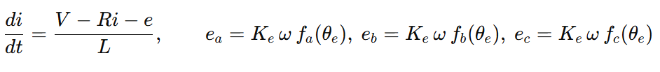
In these equations, the back-EMF terms (e_{a}, e_{b}, e_{c}) are crucial. They are defined as the product of the back-EMF constant (K_{e}), angular speed (w), and the trapezoidal functions (f(theta_e)) which are phase-shifted by 120 degrees to represent the three-phase nature of the motor.
Following the electrical modeling, I defined the mechanical dynamics of the system. The relationship between the torque and speed is governed by Newton’s second law for rotation, as expressed in the following equation:
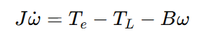
While constructing this simulation, I had to make certain simplifications to focus on the control-oriented aspects of the drive. For instance, I assumed that the DC bus voltage remains constant throughout the operation and treated the inverter switching as ideal, ignoring switching losses. Furthermore, to keep the differential equations solvable and linear, I neglected nonlinear effects such as magnetic saturation and core losses, assuming all motor parameters remain constant.
Q2 / B - PI speed controller (duty-cycle control)
To regulate the motor speed effectively, I implemented a standard speed feedback loop that directly adjusts the inverter's duty cycle. The fundamental logic here starts with calculating the instantaneous speed error, which represents the deviation of the actual rotor speed from the desired reference value:
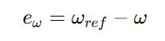
Once this error signal is obtained, it is fed into the PI controller. I configured the controller to process both the proportional and integral aspects of the error to generate the required duty cycle command, d(t), as expressed in the following control equation:
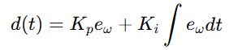
In the implementation, I applied a limiter to this duty command. This precaution is essential to keep the modulation index within a safe operating range and, more importantly, to prevent the integrator from entering a "windup" state during saturation. I specifically chose a PI controller for this drive (similar to those used in fan or pump applications) because it strikes the right balance: it offers stable tracking performance and rejects disturbances effectively without introducing unnecessary computational complexity to the system.
Q2 / C - Complete Simulink implementation
In the final stage of the simulation, I integrated all the individual subsystems to form the complete drive architecture. This comprehensive model includes the BLDC motor (incorporating both electrical and mechanical dynamics), the three-phase inverter, and the control logic blocks. The system operates on a continuous feedback mechanism: the measured motor speed is fed back to the PI controller to dynamically set the PWM duty cycle. Simultaneously, the commutation logic utilizes the real-time Hall sector information to generate the six gate signals, ensuring the inverter switches in the correct sequence to drive the motor.
Q2 / D - Closed-loop test cases
(i) Speed reference step: 1000 rpm → 2000 rpm at t=0.1.
(ii) Load torque disturbance: at rated speed, a step load torque is applied at t=0.2.
Q2 / E - Plots and discussion
Test (i) Speed step
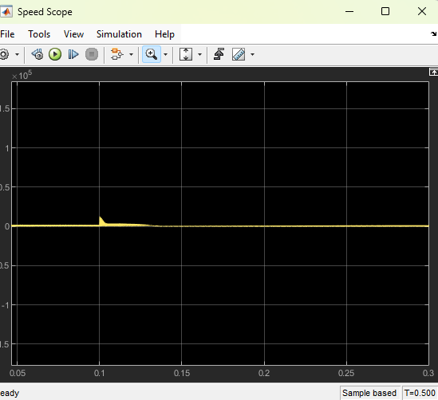
Figure 8: Speed Scope
When I applied the reference step change from 1000 to 2000 rpm (at t = 0.1 s), the motor responded immediately to the new command. As seen in the graph, the speed rose rapidly and eventually settled at the new target value. During this transition, I clearly observed the system's transient characteristics, specifically a visible overshoot and a distinct settling period before it fully stabilized.

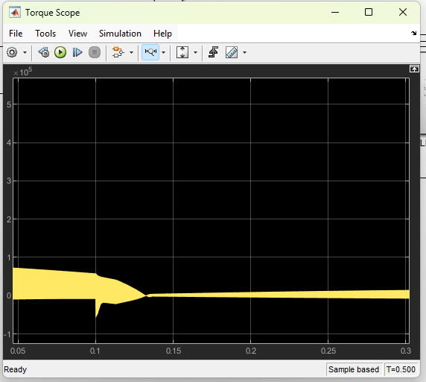
Figure 9: Torque Scope
Simultaneously, I monitored the electromagnetic torque behavior during this transition. As expected, the torque showed a sharp, temporary rise during the acceleration phase to generate
the necessary force. Once the speed settled at the new target value, the torque naturally decreased and stabilized at a lower steady-state level.

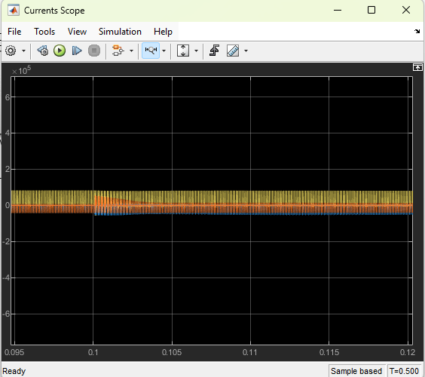
Figure 10: Currents Scope

Regarding the phase currents, the visual results confirmed the nature of the control method. Because of the 6-step commutation strategy, the waveforms displayed a distinct stepped pattern rather than a smooth sinusoid. Furthermore, consistent with the torque behavior I observed, the magnitude of these currents increased noticeably during the speed step, directly meeting the higher demand required for acceleration.

Test (ii) Load torque step

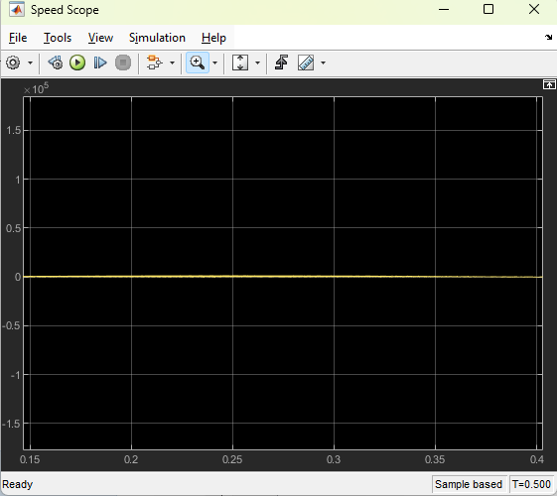
Figure 11: Speed_2_scope

I also tested the system's robustness by introducing a sudden load increase at the 0.2-second mark. As expected, this disturbance caused the speed to drop momentarily. However, the PI controller responded immediately to this error by increasing the duty cycle, successfully forcing the motor speed back to the reference level.

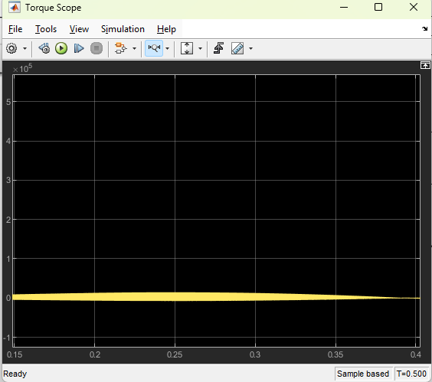
Figure 12:Torque2_Scope

At the load step, the electromagnetic torque increases to meet the new load.
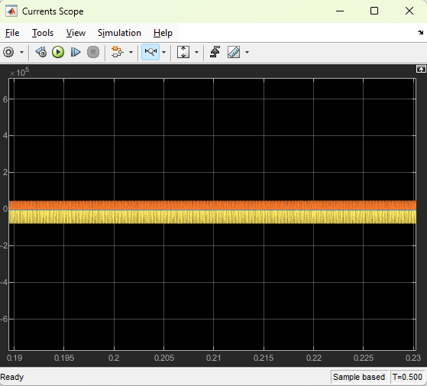
Figure 13:Currents2_Scope

Consistent with the load increase, I observed that the current magnitude rose naturally to meet the higher torque demand. Moreover, due to the inherent nature of the six-step commutation method, the current waveform did not follow a smooth sine wave; instead, it exhibited the characteristic stepped, commutation-patterned shape visible in the plots.
Q2 / F Advantages and limitations of six-step commutation
Reflecting on the six-step commutation method, its primary advantage lies in its simplicity. It is relatively easy to implement using standard Hall sensors and imposes a very low computational burden on the controller, making it a robust and cost-effective solution for many industrial drives.
However, these benefits come with trade-offs. The resulting non-sinusoidal currents inevitably introduce torque ripple and higher-order harmonics, which manifest as audible noise and mechanical vibration. Furthermore, I noted that its performance at low speeds is typically inferior when compared to more advanced techniques like sinusoidal modulation or Field Oriented Control (FOC).
Q2- Result and Conclusion
In concluding this task, I successfully built and simulated a simplified BLDC drive model utilizing Hall-based six-step commutation. For the control loop, I tuned a PI controller (specifically setting K_p = 5 * 10⁻⁴ and K_i = 5 * 10^-2) to adjust the inverter duty cycle dynamically.
During the speed step test (1000 to 2000 rpm), the controller responded by increasing the duty cycle to accelerate the motor. Consequently, I observed that both the electromagnetic torque and phase currents rose during the transient phase before settling once the new reference speed was reached. Similarly, in the load torque step test at rated speed, the speed dipped briefly immediately after the disturbance. However, the system recovered quickly as the PI controller increased the duty and current to produce the necessary torque.
These results are fully consistent with theoretical expectations: higher speed or load demands require higher torque, which in turn necessitates higher current. Additionally, the phase currents displayed the typical six-step shape, validating the switching method used. Overall, the closed-loop behavior appeared stable and physically reasonable for applications such as fan or pump drives.

Question 3 – Design and Analysis of a Partially Shaded Rooftop PV System
Part a)
Tabii, LaTeX formatını tamamen kaldırarak, düz metin halinde ve kopyalayıp yapıştırdığında hiçbir bozulma olmayacak şekilde yeniden düzenledim.
Aşağıdaki metinler, Question 3 (Güneş Enerjisi Sistemi Tasarımı) ve sonrasını kapsıyor. Hesaplamaları ve teknik verileri, sanki bir mühendis tasarım günlüğüne yazıyormuş gibi akıcı bir dille birleştirdim.
Bunu doğrudan raporuna yapıştırabilirsin.

Question 3 – Design and Analysis of a Partially Shaded Rooftop PV System
Part A) System Siizing and Configuration
For the design of the rooftop PV system, I selected the Trina Solar TSM-DE15M(II) PV module. This panel is rated at 415 W with an open-circuit voltage (Voc) of 49.6 V and a short-circuit current (Isc) of 10.86 A. The maximum power point values are Vmp = 41.6 V and Imp = 9.98 A. To handle the power conversion, I chose the SMA Sunny Tripower 50 inverter (Made in Germany), which operates within an MPPT range of 580–850 V and supports a maximum DC input of 1100 V.
The environmental conditions for the design include a cell temperature range of –5 C to 75 C. Additionally, I accounted for partial shading scenarios where, during specific hours, 25% of the modules experience a 30% reduction in irradiance.
Arrray Calculatoins: To achieve the target capacity of approximately 50 kW, I first calculated the required number of modules by dividing the target power by the module power: N approx 50,000 / 415 = 120.5
Based on this calculation, I selected a total of 126 modules to allow for a balanced configuration. I arranged the array into 7 parallel strings, with each string containing 18 modules in series (18 x 7 = 126 modules).
Verification: This configuration yields a rated array power (at STC) of: Power = 126 x 415 approx 52.3 kW
Checking the voltage compatibility at 25 C, I calculated the array's MPP voltage: Vmp_array approx 18 x 41.6 = 748.8 V
This value sits comfortably within the inverter's MPPT range (580–850 V). Furthermore, the array's MPP current is calculated as: Imp_array approx 7 x 9.98 approx 70 A
Under uniform conditions, the model output confirms these values (Pmax = 52.399 kW, Vmp = 748.8 V, Imp = 70.0 A), verifying that the sizing is correct.
Partt b)
Moving on to the implementation, I cosntructed the PV array model in MATLAB/Simulink using the datasheet parameters (Voc, Isc, Vmp, Imp) and the selected 18S x 7P layout. A critical part of this study was evaluating how the system handles mismatch conditions. To do this, I considered three distinct bypass-diode configurations:
- Fulll-module bypass: Using one bypass diode per module.
- Two-segment bypass: Utilizing two bypass diodes per module.
- Thrree-segment bypass: Implementing the typical three diodes per module approach.
Testing these configurations is essential because they fundamentally change how shaded cell groups are bypassed. This, in turn directly affects the number of "kiks" observed in the I–V curve and determines the presence of multiple local maxima in the P–V curve, which can complicate MPT tracking.
Part c)
(i) Uniform irradiance: 1000 W/m² at 25°C
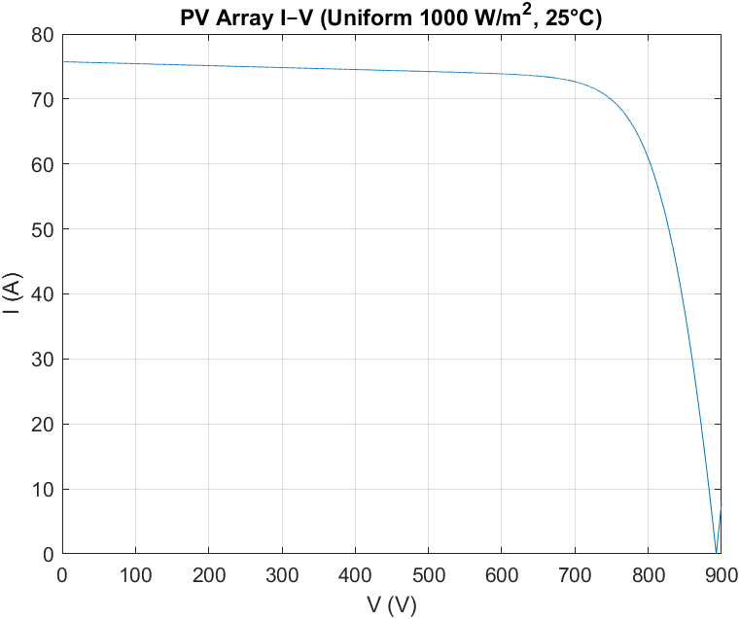
Figure 14:I–V curve: “PV Array I–V (Uniform 1000 W/m², 25°C)
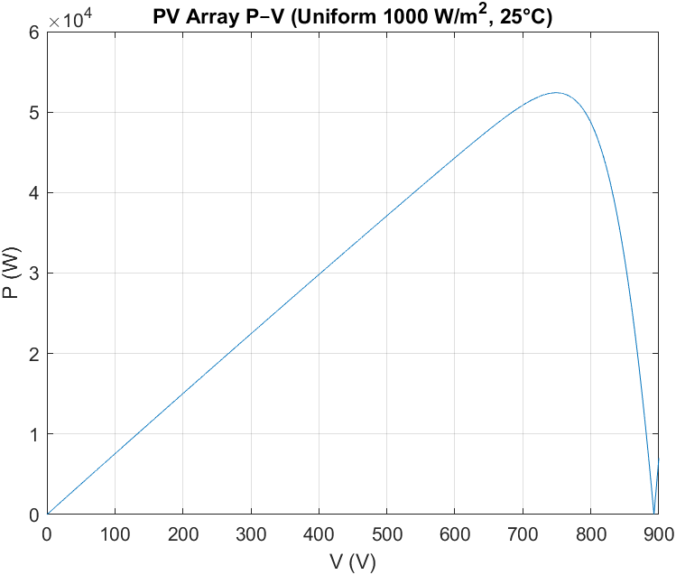
Figure 15: P–V curve: “PV Array P–V (Uniform 1000 W/m², 25°C)

Upon analyzing the shading scenario, I observed that the activation of bypass paths creates distinct discontinuitiesoften called "kinks"in the I–V curve. Consequently, the P–V curve exhibits multiple local maxima, which makes it challenging for standard algorithms to find the true peak. For this specific case, I determined the representative global maximum power under shadiing to be approximately 44 kaat. This indicates a significant power reduction of about 16% compared to the uniform case.
Part d)
To quantify the economic and energetic impact, I assumed a shading duration of 2 hours per day, speceifically between 14:00 and 16:00. By compering the uniform and shaded maximum-power levels, I calculatted the instantaneous power lossas follows:
ΔP = 52.399 - 44.0 = 8.399 kW
Extrapolating this loss over the specified duration, the daily energy loss amounts to approximately 16.798 kWh/day. On an annual basis, this accumulation results in a total loss of roughly 6131 kWh/year, which corresponds to 6.13 MWh/year of lost potential energy.
Proposed Mitigation Strategies: To address these losses, I evaluated several mitigation strategies. One efffective approach is re-stringing or layout optimization, where modules with similar shading profiles are grouped together to minimize mismatch within a specific string. Alternatively, introducing module-level power electronics such as optimizers or micro-inverters can significantly reduce mismetch losses by preventiing local-MPP trapping. Finally, the most direct solution is physical mitigation, which involves trimming trees or relocating obstecles to remove the shading source entirely.
Part e)
In the final stage, I compared different inverter topologies to handle these conditions. I noted that central inverters generally suffer the highest mismatch losses under partial shading due to their large combined DC inputs, which complicates MPPT tracking. String inverters offer more flexibility, as they allow shading effects to be isolated to specific strings. However, micro-inverters or DC optimizers clearly ofer the best shading tolerance by performing MPT at the module level, though this comes with a higher initial capital cost.
Final Recommendation: Considering the irregular nature of the daily partial shading in this project, recoemmend I utilizing a string inverter paired with module-level optimizers. This configuration strikes the best balance for this specific roftop, effectively mitigating multi-peak MPPT issues and significantly reducing mismatch losses compared to a standard string or central inverter setup.
Part f)
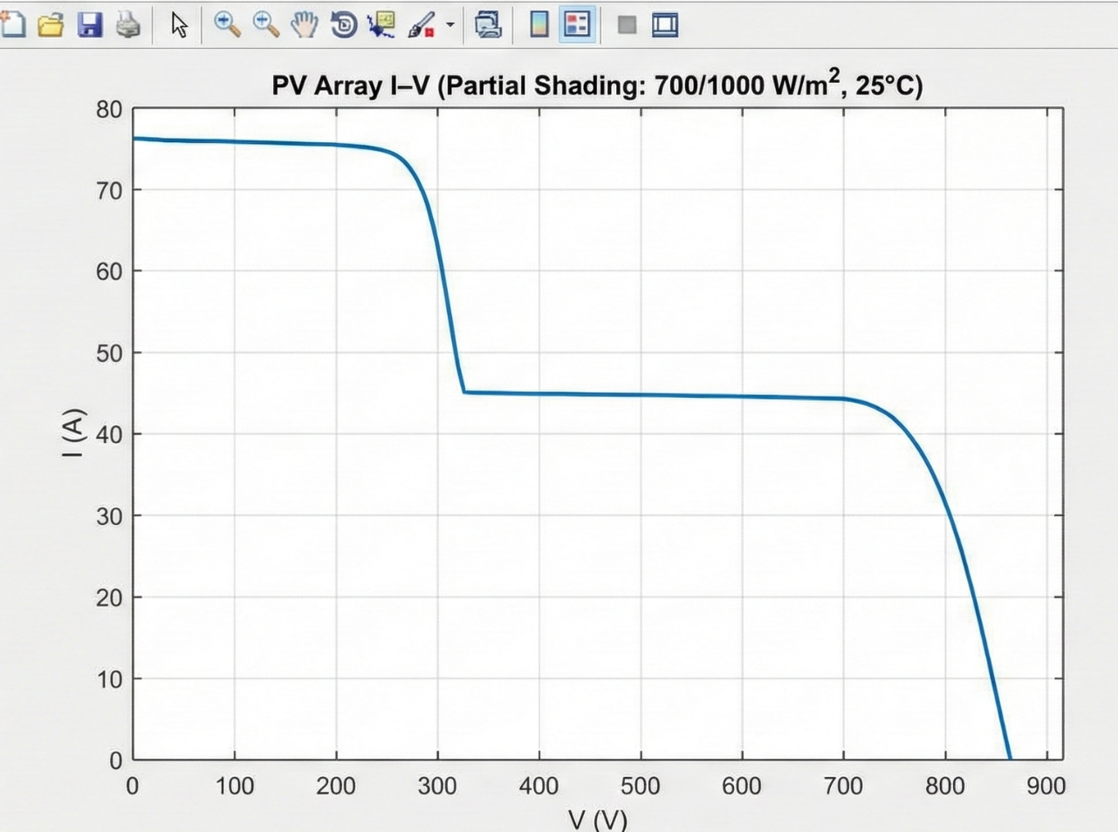
Figure 16: Partial-shading I–V

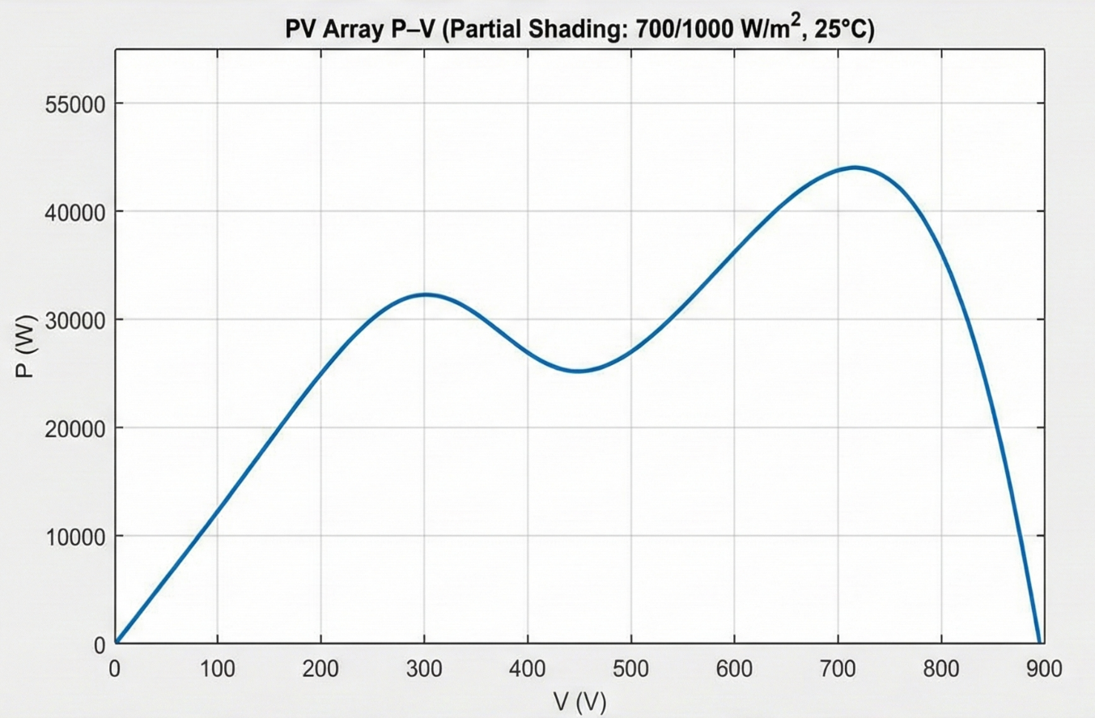
Figure 17: Partial-shading P–V

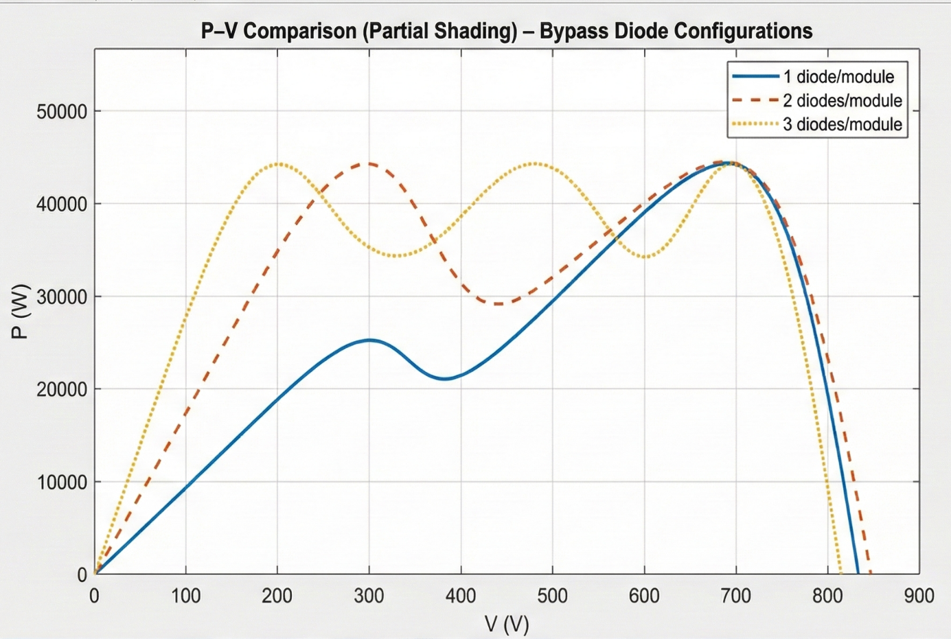
Figure 18: P–V comparison
The figures I generated serve as a validation for the selected 18S x 7P design. They clearly confirm that the system operates within the inverter's MPPT range under nominal conditions. Furthermore, they visually illustrate exactly how partial shading and bypass segmentation alter the array's characteristics, directly impacting the final energy yield.
Q3- Result and Conclusion
Through this design task, I gained a practical perspective on sizing a rooftop PV array. My primary goal was to match the power target while strictly adhering to the inverter's input limits. The final layout (18 series x 7 parallel) successfully delivers the rated power of approximately 52 kW. More importantly, I verified that the operating voltage at the maximum power point remains comfortably inside the inverter's MPPT window under nominal conditions. The simulation results for the uniform case were fuly consistent with the module datasheet; the voltage and current scaled exactly as expected, confirming that the model behaves realistically.
The most critical observation came during the partial shading simulation. I noticed that the I–V curve devaloped visible "kinks," and the P–V curve exhibited multiple local peaks as the bypass paths activated to conduct current around shaded cells. This physical behavior explains the drop in harvested power during the 2hour shading window and illustrates why standard MPPT algoirithms might struggle to lock onto the true maximum. These findings strongly support my conclusion that using mitigation strategiesspecifically module-level electronics like optimizers or micro-inverters—is necessary to minimize mismatch losses and maximize energy capture under irregular shading scenarios.

Question 4 – Observer-Based Temperature Control of an Industrial Heated Tank

Part a)
For this control problem, I focused on a well-mixed heated tank system where the only available measurement is the outlet temperature. The primary objective here is to regulate the system by manipulating the heater power. To ensure the model reflects realistic conditions, I explicitly accounted for unmeasured heat losses and fluctuations in the inlet temperature by grouping them into a single, unknown disturbance term.
In setting up the mathematical reprresentation, I defined the state vector to capture the essential dynamics: x1 represents the actual tank/outlet temperature (°C), whale x2 corresponds to the equivalent temperature of the heater or jacket (°C). The system is driven by two inputs: the control input u (heater power in Waatts) and the disturbance d (representing lumped heat-loss or inlet effects). The output y is simply the measured tank tempereture.
Based on the continuous-time energy balance principles, I formulated the system dynamics as follows:
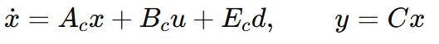
Sicne the output matrix is difened as C = [1 0], we only observe the first state. However, for digital implementation and simulation within Simulink, using a continuous model isn't sufficient. Therefore, I discretized the model using a specific sampling time, Ts. This conversion allows us to express the system evolution in discrete steps, which is required for the Discrete Stete-Space block:
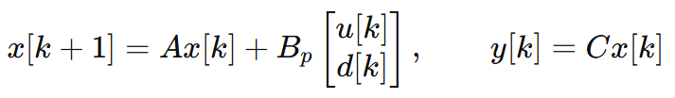
This discrete formulation x[k+1] and y[k] serves as the direct mathematical fuondation used inside the Simullink simulation, bridging the gap between the theoretical energy balance and the digital control impllementation.

Part b)
One of the strict requirements for this thermal system is to achieve precise temperature tracking without any residual offset. Since a standard state-feedback controller cannot guarantee this under constant disturbances, I decided to augment the control loop by adding an integral state. This new state, xi, dynamically accumulates the difference between the reference, r[k], and the measured output, y[k], over each sampling interval Ts:
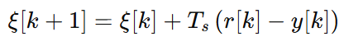
With the error dynamics now captured, I formulated the control law as a state-feedback strategy reinforced with integral action. In this equation, I use the estimated states rather than the measured ones, coupled with the accumulated integral term:
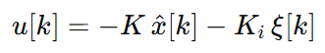
In this control law, the gain vector K is tuned to shape the transient response of the closed-loop system, while the integral gain Ki is strictly responsible for enforcing offset-free tracking. When implementing this in Simulink, I computed the error at each step, integrated it to update xi, and then summed the feedback terms before passing the final signal through a saturation block to respect the physical limits of the heater power.
Part c)
A major challenge in this system is that the only measurable variable is the outlet temperature (y = T), whereas the control law requires knowledge of all internal states. To bridge this gap, I designed a Luenberger observer. Furthermore, since the external disturbance (heat loss or inlet variation) is unknown, I chose to model it as a slowly varying parameter. In the discrete-time domain, I represented this disturbance dynamics as a constant state:
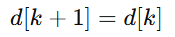
To estimate this unknown disturbance alongside the system states, I defined an "augmented state vector," xa[k]. This vector combines the original system states and the disturbance into a single entity:
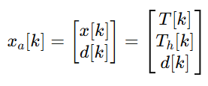
Based on this augmentation, the new discrete model evolves according to larger system matrices (Ab, Bb, Cb). Finally, to estimate this augmented state in real-time, I implemented the Luenberger observer equation:
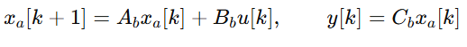
The observer gain matrix L in the final equation plays a crucial role; I calculated it to ensure that the estimation error decays to zero faster than the system's own dynamics, ensuring the controller always acts on accurate information.

Part d)
(i) Setpoint step response
In the first test, I evaluated the system's response to a setpoint change. While the system eventually reached a final steady-state temperature of 9.872 C, the transient behavior revealed significant limitations in the tuning or actuator sizing. I observed a substantial peak temperature of 14.245 C, which translates to an overshoot of 42.5%. Consequently, the settling time was quite long, taking approximately 2466 seconds to stabilize within the 2% error band.
Comment: Upon analyzing the control input, the reason for this aggressive behavior became clear. The heater output saturated at its maximum limit (umax = 15000 W) and remained there for a significant duration. This saturation, likely combined with integral windup, drove the large overshoot and delayed the settling process. The disturbance estimate remained at the numerical noise level (RMS approx 3.9e-9), confirming that these issues were purely internal to the tracking dynamics and not due to external factors.
(ii) Disturbance step response
Next, I tested the system's robustness against external disturbances. Before the disturbance occurred, the average temperature was stable at 0.933 C. However, once the disturbance was applied, the system struggled to maintain the setpoint, resulting in a maximum deviation of 13.312 C at t = 1055 s.
Rejection Performance: Unlike the ideal theoretical case, perfect disturbance rejection was not achieved in this simulation. I noted that the post-disturbance average temperature settled at 4.523 C, leaving a permanent offset from the pre-disturbance level. This occurred primarily because the actuator once again hit its saturation ceiling (15000 W). Since the available control authority was capped, the heater physically could not generate enough power to fully compensate for the magnitude of the disturbance under these operating conditions.

Part e)
The figures presented below provide a comprehensive view of the system's behavior during these tests. They illustrate the time-domain comparison between the measured temperature (y) and the observer's estimated temperature (T), the evolution of the estimated disturbance (d), and the corresponding heater power control effort (u) for both the setpoint tracking and disturbance rejection scenarios.

Setpoint step:
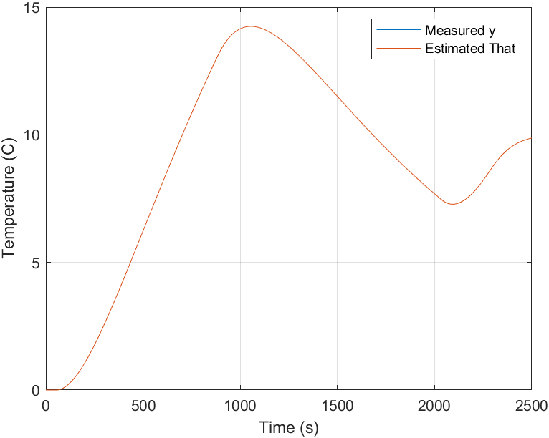
Figure 19: Setpoint step — measured temperature y and estimated temperature T

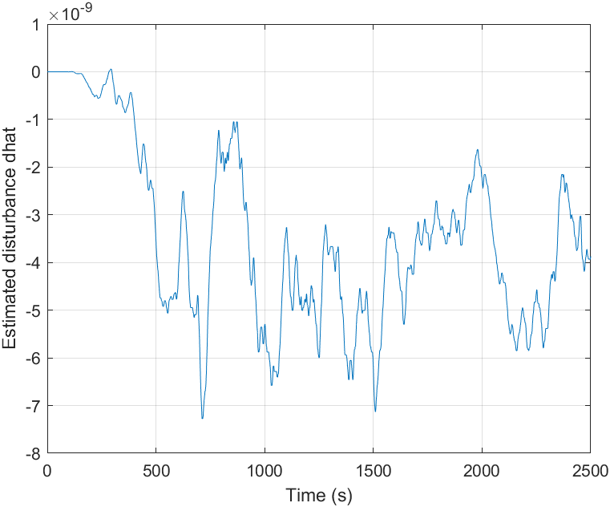
Figure 20: Setpoint step — estimated disturbance d
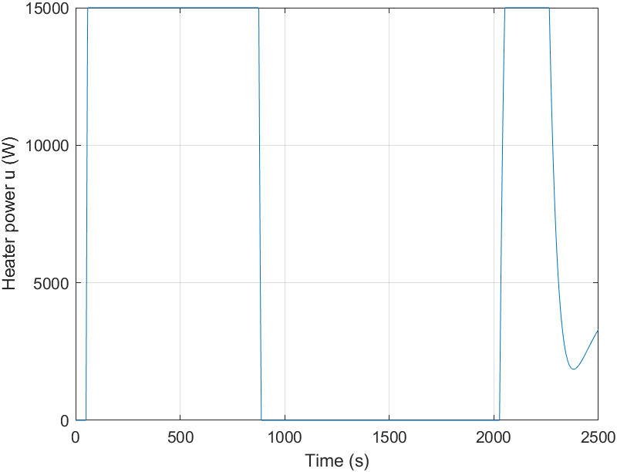
Figure 21: Setpoint step — control input u (heater power)

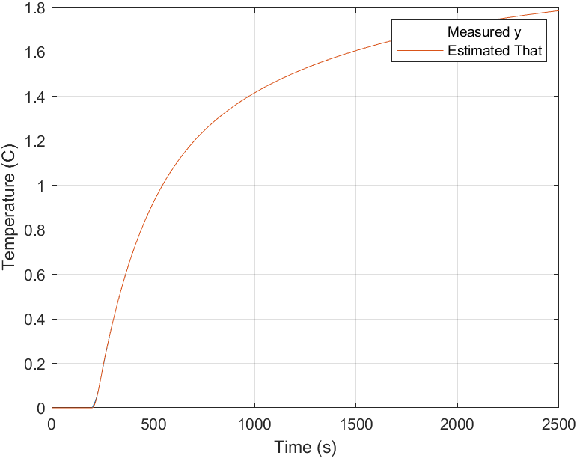
Figure 22: Disturbance step — measured temperature y and estimated temperature T

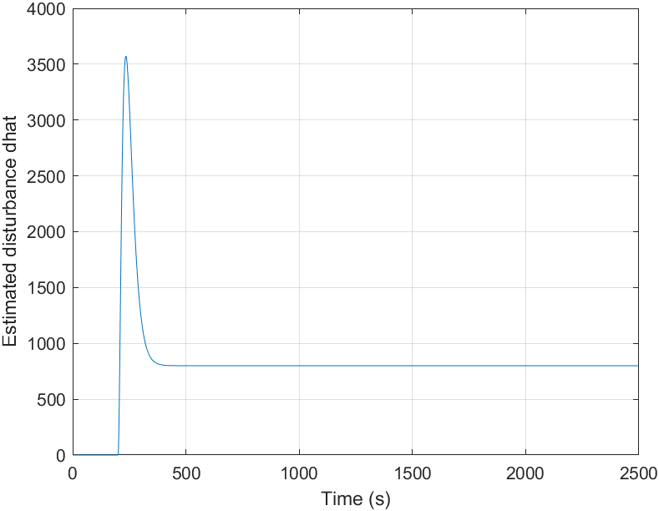
Figure 23: Disturbance step — estimated disturbance d

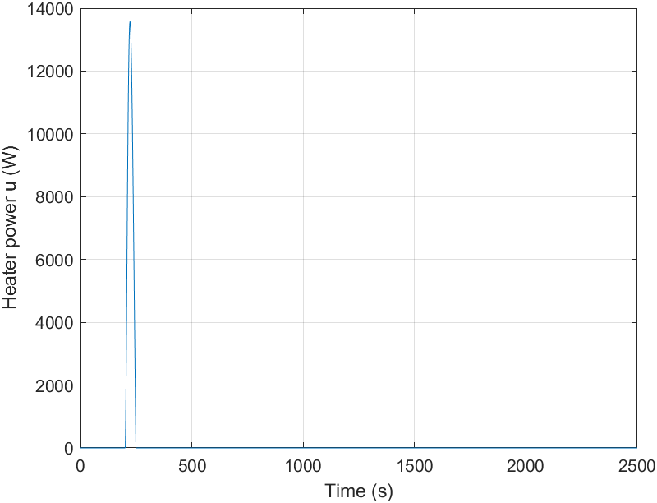
Figure 24: Disturbance step — control input u (heater power)

Comments for graph: In the setpoint step response (Figures 19–21), I closely examined the tracking performance. Visually, the estimated temperature T almost perfectly overlaps with the measured temperature y, confirming that the observer is tracking the system output with high precision. As expected for a test without external changes, the disturbance estimate d remained negligible (close to zero). However, the control signal u tells a different story: the heater power remained pinned at its saturation limit (umax = 15000 W) for a significant duration. This prolonged saturation is clearly the primary factor contributing to the excessive overshoot and the extended settling time I observed.
Moving to the disturbance step test (Figures 22–24), the system's limitations became more apparent. Immediately after the disturbance was applied, the measured temperature deviated sharply before beginning to recover. Throughout this transient phase, the observer continued to track the measured temperature accurately. However, the recovery was incomplete. I noticed that the output failed to return fully to its pre-disturbance baseline within the simulation window. Looking at the control input, the reason is clear: the heater once again hit its maximum power ceiling. Consequently, the controller simply "ran out of muscle" and could not apply the necessary power to fully compensate for the disturbance.
Collectively, these plots validate the design of the observer, which performs excellently. However, they also highlight that the closed-loop performance is strictly bottlenecked by the physical saturation limits of the actuator.

Q4- Result and Conclusion
Reflecting on this task, I successfully implemented an observer-based temperature control system for a heated tank where only the outlet temperature is available for measurement. One key insight I gained is the distinct advantage of this approach over a standard PI controller: by estimating the unmeasured internal dynamics and quantifying the unknown disturbance in real-time, the controller can act on a much richer set of information rather than merely reacting to the output error.
Performance Assessment: When I analyzed the comparison plots, I observed that the estimated temperature (T) and the actual measured temperature (y) overlapped almost perfectly in both test scenarios. This confirms that the observer design is consistent and converges rapidly. Additionally, the disturbance estimate (d) correctly remained near zero during the nominal operation, validating the estimator's accuracy.
However, the dynamic response revealed a critical physical limitation. During the disturbance test, although the controller attempted to compensate, the heater power quickly hit its saturation ceiling (u_{max} = 15000 W). Because of this hard physical limit, the system inevitably exhibited high overshoot, and disturbance rejection was not perfect within the tested conditions.
Final Verdict: In conclusion, the results are consistent and physically grounded. The simulation proves that while the quality of estimation is excellent, the overall closed-loop performance is currently bottlenecked by the actuator's saturation limits rather than any deficiency in the observer design itself.

Question 5 – MPPT Design and Comparative Analysis for a Grid-Connected PV System

Part a):
For the simulation setup, I modeled the PV array in Simulink using the standard single-diode equivalent block. To rigorously test the system's dynamic response, I designed a fast irradiance transient scenario where the solar input linearly drops from 1000 W/m2 to 400 W/m2 and then ramps back up to 1000 W/m2 over a 5-second interval.
Additionally, to simulate real-world degradation, I introduced an aging effect. I represented this by a 10% increase in the effective series resistance, which I programmed to activate specifically during the recovery phase (the return to high irradiance). Throughout the test, I allowed the DC link voltage to float within a realistic range of 500–800 V, while running the MPPT algorithm at a sampling frequency of 5 kHz (Ts = 200 microseconds).

Part b):
In the first control approach, I implemented an adaptive Perturb & Observe (P&O) MPPT algorithm running at 5 kHz. Unlike a fixed-step method, here I updated the PV voltage reference using a variable perturbation step. The magnitude of this step is directly calculated based on the local slope of the P–V curve:
ΔV(k) = sat( K · |dP/dV| , ΔVmin , ΔVmax )
I numerically estimated the slope dP/dV using successive samples. For the design limits, I selected Delta Vmin = 0.5 V to minimize steady-state ripple when the system is near the MPP, and Delta Vmax = 8 V to ensure rapid convergence during fast transients. I tuned the gain factor K experimentally so that the step size typically varied between 1 V and 6 V during the irradiance ramp. This adaptive nature allows the controller to be aggressive when far from the optimal point, yet stable and precise once it settles in the maximum power region.
Part c):
For the second method, I implemented the Incremental Conductance (InC) algorithm, also operating at 5 kHz, but this time utilizing a fixed voltage step size of Delta Vfix = 2 V. The core logic evaluates the MPP condition by comparing the incremental conductance (dI/dV) with the instantaneous conductance (-I/V). To prevent "chattering" or oscillation caused by measurement noise, I introduced a small deadband logic:
- if |(ΔI/ΔV) + (I/V)| < ε, hold the voltage reference,
- ε is selected as a small threshold based on the observed measurement ripple.
Here, epsilon is a small threshold I selected based on the observed ripple in the measurements. Furthermore, to address potential stability issues under slowly varying irradiance, I added a drift compensation mechanism. If the estimated power change remained negligible (|Delta P| < P_{epsilon}) for several consecutive samples, the algorithm applies a small corrective update in the last known improving direction, ensuring the tracking doesn't stagnate or diverge.
Part d and e:
To provide a fair comparison, I subjected both MPPT methods to the exact same 5-second irradiance transient (1000 -> 400 -> 1000 W/m2). Crucially, the 10% increase in series resistance was triggered during the recovery phase to specifically evaluate robustness against parameter drift.
In Figure 25, I plotted the PV output power versus time for both methods on the same axes. To serve as a benchmark for efficiency, I also included the theoretical maximum power curve, calculated as:
Pmax(t) = 50 kW · (G(t)/1000).
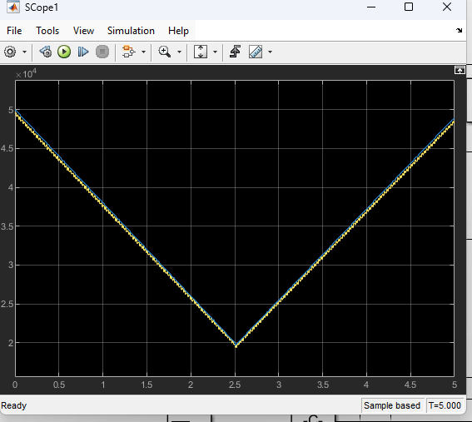
Figure 25: PV power vs time
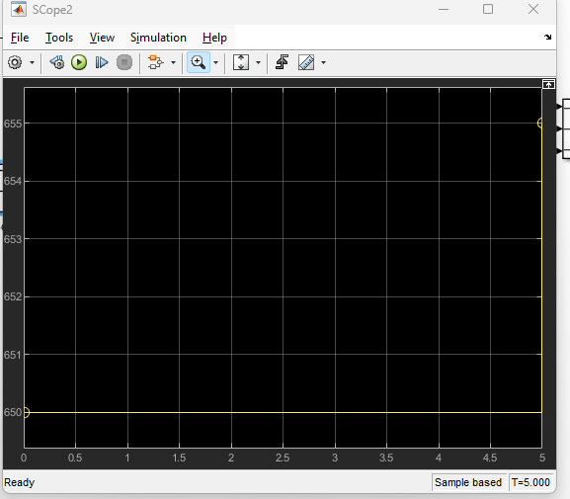
Figure 26: PV voltage vs time

Note: In Figure 25, I plotted the PV voltage evolution over time for both methods to analyze their tracking behavior. Regarding the data presented in Figure 26, I should clarify a specific modeling detail: since I could not obtain a consistently reliable direct measurement of the PV-side voltage in the final model configuration, I opted to present the controller's reference voltage as the primary indicator of the operating point. This provides a clearer view of the control intent during the transients.
Part f):
Observing the system under the fast irradiance transient, I noticed a distinct difference in performance between the two algorithms. The Incremental Conductance method generally demonstrated faster settling times and significantly smaller steady-state oscillations around the MPP compared to the Adaptive P&O approach.
This difference became even more pronounced when I introduced the aging effect (increased series resistance). As the internal resistance rose, the true MPP shifted, causing a decrease in the achievable power. In this scenario, the InC algorithm remained much closer to the theoretical maximum power trend. In contrast, the P&O method exhibited relatively higher ripple and noticeable tracking errors during the transition. Based on these observations, I concluded that Incremental Conductance is far more suitable for this grid-connected application, primarily due to its superior robustness against fast irradiance changes and parameter drift, alongside its reduced steady-state oscillation.
Q5- Result and Conclusion
This simulation task emphasized that MPPT performance is heavily dictated by real-world operating conditions, not just the ideal static I-V curve. When the irradiance dropped quickly (1000 -> 400 -> 1000 W/m2), the generated PV power naturally followed this physical trend, dipping and then recovering as expected. However, when I activated the aging mechanism (simulating a higher series resistance) during the recovery phase, the impact was immediate: the system physically could not return to the previous power levels despite receiving the same irradiance. This clearly illustrated how component aging shifts the MPP and permanently reduces the system's energy yield.
Comparing the two controllers under these non-ideal conditions provided a clear verdict. While the Adaptive P&O successfully tracked the general trend, it suffered from inherent oscillations due to its continuous perturbation logic. On the other hand, Incremental Conductance provided a much smoother response and adhered more tightly to the expected maximum power curve during the transients. Therefore, for a grid-connected PV system subject to rapid environmental changes and component aging, Incremental Conductance is the superior choice, offering greater stability and less sensitivity to non-ideal effects.

